

**i-LAN Technology Pty Ltd**

17

**DrayTek Training**

**DrayTek WAN Connectivity Options**

**Roy Panetta**

Table of Contents

[Introduction 3](#_Toc477870580)

[Types of Routers 3](#_Toc477870581)

[xDSL Routers 3](#_Toc477870582)

[Broadband Routers 5](#_Toc477870583)

[LTE Routers 7](#_Toc477870584)

[WAN Connectivity Options 7](#_Toc477870585)

[xDSL WAN (ADSL2/2+, VDSL2) 8](#_Toc477870586)

[ADSL 8](#_Toc477870587)

[VDSL 10](#_Toc477870588)

[Checking the VDSL Connection Status 12](#_Toc477870589)

[Ethernet WAN 14](#_Toc477870590)

[Configuration of Ethernet WAN 14](#_Toc477870591)

[USB WAN 17](#_Toc477870592)

[WAN Access Modes 17](#_Toc477870593)

[LTE WAN 19](#_Toc477870594)

[LTE Configuration 19](#_Toc477870595)

[Checking the Status of LTE WAN 21](#_Toc477870596)

[Fibre WAN 22](#_Toc477870597)

[Wireless (Wi-Fi) WAN 22](#_Toc477870598)

[Configuring Wireless WAN 23](#_Toc477870599)

[Additional Resources 26](#_Toc477870600)

[Exercises 26](#_Toc477870601)

# Introduction

DrayTek routers support a variety of WAN connectivity options. Routers are available in single, dual and multi-WAN versions. In this training guide we will go through each WAN connectivity option and the configuration parameters involved.

# Types of Routers

## xDSL Routers

These routers will have at least one WAN interface that will be either ADSL or VDSL. The dual WAN routers will have one xDSL WAN interface and an Ethernet WAN Interface. The tables below provide a list of these routers and the type of WAN interface available.

|  |  |  |  |
| --- | --- | --- | --- |
| **Single WAN Routers – Only one WAN is active** | | | |
| **Router Model** | **WAN Type** | | |
|  | **WAN 1** | **WAN 2** | **WAN 3** |
| Vigor120 | ADSL2+ | - | - |
| Vigor130 | ADSL2+/VDSL2 | - | - |
| VigorNIC 132F | ADSL2+/VDSL2 | SFP | - |
| Vigor2710ne | ADSL2+ | - | - |
| Vigor2760 Series | ADSL2+/VDSL2 | LAN 4 (Gigabit Ethernet) | USB backup |

|  |  |  |
| --- | --- | --- |
| http://www.draytek.com.au/wp-content/uploads/2017/01/Vigor120_2017-300x211.png | http://www.draytek.com.au/wp-content/uploads/2017/01/Vigor130_2017-300x211.png | vigornic-132f_1024x720 |
| Vigor120 | Vigor130 | VigorNIC 132F |
|  |  |  |
| http://www.draytek.com.au/wp-content/uploads/2017/01/Vigor2710ne_2017-300x211.png | http://www.draytek.com.au/wp-content/uploads/2017/01/Vigor2760Vn_2017-300x211.png |  |
| Vigor2710ne | Vigor2760 Series |  |

|  |  |  |  |  |
| --- | --- | --- | --- | --- |
| **Dual WAN Routers – Multiple WANS can be active at same time** | | | | |
| **Router Model** | **WAN Type** | | | |
|  | **WAN 1** | **WAN 2** | **WAN 3** | **WAN 4** |
| Vigor2832 Series | ADSL2+ | Gigabit Ethernet | USB | USB |
| Vigor2860 Series | ADSL2+/VDSL2 | Gigabit Ethernet | USB | USB |
| VigorBX 2000 | ADSL2+/VDSL2 | Gigabit Ethernet | USB | USB |

|  |  |
| --- | --- |
| http://www.draytek.com.au/wp-content/uploads/2017/01/Vigor2832n_2017-300x211.png | http://www.draytek.com.au/wp-content/uploads/2017/01/Vigor2860Vac_2017-300x211.png |
| Vigor2832 Series | Vigor2860 Series |
|  |  |
| Vigor BX2000 |  |
| VigorBX 2000 Series |  |

## Broadband Routers

Broadband routers will have one or more Ethernet WAN interfaces. These routers can be connected to a NBN NTU (Network Termination Unit) for services like FTTH/FTTP (Fibre to the Premise), HFC, Satellite, or fixed wireless. . The tables below provide a list of these routers and the type of WAN interface available.

|  |  |  |  |
| --- | --- | --- | --- |
| **Single WAN Routers – Only one WAN is active** | | | |
| **Router Model** | **WAN Type** | | |
|  | **WAN 1** | **WAN 2** | **WAN 3** |
| Vigor2120 Series | Gigabit Ethernet | USB backup | - |
| Vigor2132 Series | Gigabit Ethernet | - | - |

|  |  |
| --- | --- |
| Vigor2120n-Plus | http://www.draytek.com.au/wp-content/uploads/2015/09/Vigor2132ac-1024x720-apc-recommended-1024x720.png |
| Vigor2120 Series | Vigor2132ac |

|  |  |  |  |  |
| --- | --- | --- | --- | --- |
| **Dual WAN Routers – Multiple WANS can be active at same time** | | | | |
| **Router Model** | **WAN Type** | | | |
|  | **WAN 1** | **WAN 2** | **WAN 3** | **WAN 4** |
| Vigor2912 Series | Fast Ethernet | Fast Ethernet | USB backup (Shared with WAN 2) | - |
| Vigor2925 Series | Gigabit Ethernet | Gigabit Ethernet | USB | USB |
| Vigor2952 | Gigabit Ethernet | Gigabit Ethernet/SFP | USB | USB |
| Vigor2960 | Gigabit Ethernet | Gigabit Ethernet | USB | USB |

|  |  |
| --- | --- |
| Vigor2912n | vigor2925vnp_web-1024x720 |
| Vigor2912 Series | Vigor2925 Series |
|  |  |
| http://www.draytek.com.au/wp-content/uploads/2016/04/Vigor2952-product-image-v2.png | Vigor2960 |
| Vigor2952 | Vigor2960 |

|  |  |  |  |  |  |  |
| --- | --- | --- | --- | --- | --- | --- |
| **Multi- WAN Routers – Multiple WANS can be active at same time** | | | | | | |
| **Router Model** | **WAN Type** | | | | | |
|  | **WAN 1** | **WAN 2** | **WAN 3** | **WAN 4** | **WAN 5** | **Additional WAN** |
| Vigor3220 | Gigabit Ethernet | Gigabit Ethernet | Gigabit Ethernet | Gigabit Ethernet | USB | - |
| Vigor3900 | Gigabit Ethernet | Gigabit Ethernet | Gigabit Ethernet | Gigabit Ethernet | SFP | 2 x USB |

|  |  |
| --- | --- |
| vigor3220-new-icons | Vigor3900 |
| Vigor3220 | Vigor3900 |

## LTE Routers

These routers have an embedded 4G LTE modem. The table below provide a list of these routers and the type of WAN interface available.

|  |  |  |  |  |
| --- | --- | --- | --- | --- |
| **LTE Routers – Multiple WANS can be active at same time** | | | | |
| **Router Model** | **WAN Type** | | | |
|  | **WAN 1** | **WAN 2** | **WAN 3** | **WAN 4** |
| Vigor2860L Series | ADSL2+/VDSL2 | Gigabit Ethernet | Embedded LTE | USB |
| Vigor2925L Series | Gigabit Ethernet | Gigabit Ethernet | Embedded LTE | USB |

|  |  |
| --- | --- |
| Vigor2860 LTE Series | Vigor2925 LTE Series |
| Vigor2860L Series | Vigor2925L Series |

# WAN Connectivity Options

In addition to the physical WAN interface in the router, there are a number of different methods of establishing a connection to the service provider.

* PPPoE – Point to Point Protocol over Ethernet – Connects the users to Internet through Ethernet with a single medium: DSL, Cable or WLAN
* PPPoA – Point to Point Protocol over ATM – uses PPP dial-up protocol with ATM.
* MPoA - 1483 Bridge IP

-1483 Routed IP

MPoA is a specification that enables ATM services to be integrated with existing LANs, which

use either Ethernet, token-ring or TCP/IP protocols. The goal of MPoA is to allow different

LANs to send packets to each other via an ATM backbone.

## xDSL WAN (ADSL2/2+, VDSL2)

The xDSL WAN is suitable for premises with existing copper wires and connection to the internet can be ADSL2/2+ or VDSL2. One of the examples for deployment with DSL in the last mile is FTTB (Fibre to the Building) or FTTN (Fibre to the Node) that utilises copper wires on VDSL2 technology to end user.

### ADSL

ADSL routers have the option to select the required modulation for the Internet connection as shown in the diagram below.

|  |  |
| --- | --- |
|  | **ADSL Modulation Modes**  **T1.413** – 1.5 Mb/s downstream  **G.Lite** - ITU G.992.2 1.5 Mb/s downstream  **G.DMT** – 8Mb/s downstream, 1Mb/s upstream  **ADSL2** (G992.3) 12Mb/s downstream, 1Mb/s Upstream  **ADSL2 annex M/J** 12Mb/s downstream, 3Mb/s Upstream  **ADSL2+** (G992.5) - 24 Mb/s downstream, 1Mb/s Upstream  **ADSL2+** annex M/J -24 Mb/s downstream, 3Mb/s Upstream  **Multimode –** Router will auto-detect line type |

For ADSL connections in Australia and New Zealand we use the following settings:

|  |  |  |  |  |
| --- | --- | --- | --- | --- |
| **Parameter** | **In Australia** | | **In New Zealand** | |
| VPI | 8 | | 0 | |
| VCI | 35 | | 100 | |
| Protocol | PPPoE/PPPoA | MPoA |  |  |
| Encapsulation | LLC/SNAP | LLC |  |  |

#### ADSL Modem Codes

Draytek provides various modem codes for getting better operability with different ISPs/ IPDSLAMs. . Usually the standard modem code will be suitable for most installations, but where stability issues are encountered you can try one of the alternative modem codes.

Below we have the modem codes for the Vigor120 router. Usually the standard modem code will be suitable for most installations, but where stability issues are encountered you can try one of the other modem codes.

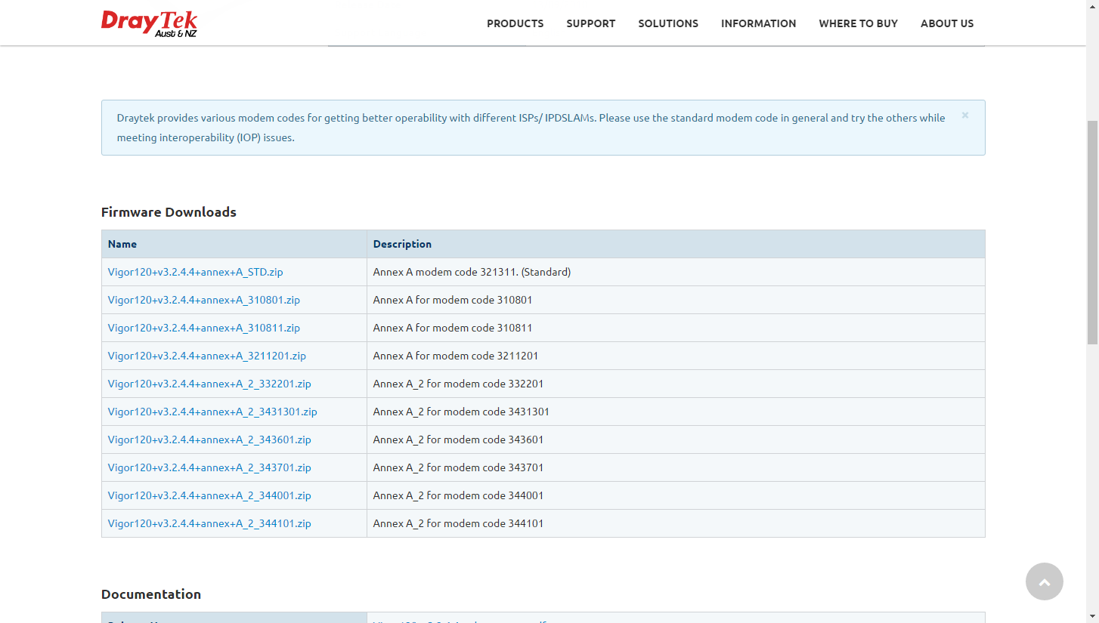

### VDSL

VDSL2 has a theoretical maximum of 350 Mbit/s at the source to 100 Mbit/s at 0.5 km and 50 Mbit/s at 1 km but degrades at a much slower rate from there. At 1.6 km its performance is equal to ADSL2+ as shown in the diagram below.

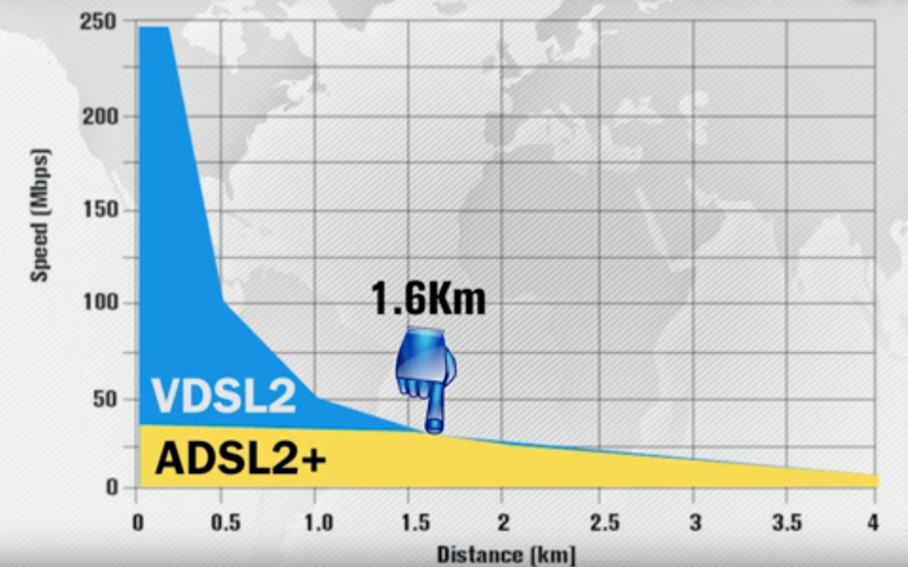

VDSL2 is used in Fibre to the Node deployment of NBN connections. Here optic fibre is installed from the NBN point of Interconnect to a node which is usually a roadside cabinet. From here existing copper cabling is utilised to provide a VDSL2 service to the premises. The distance between the node and the premises is about 300m, to ensure the required NBN speeds are provided.

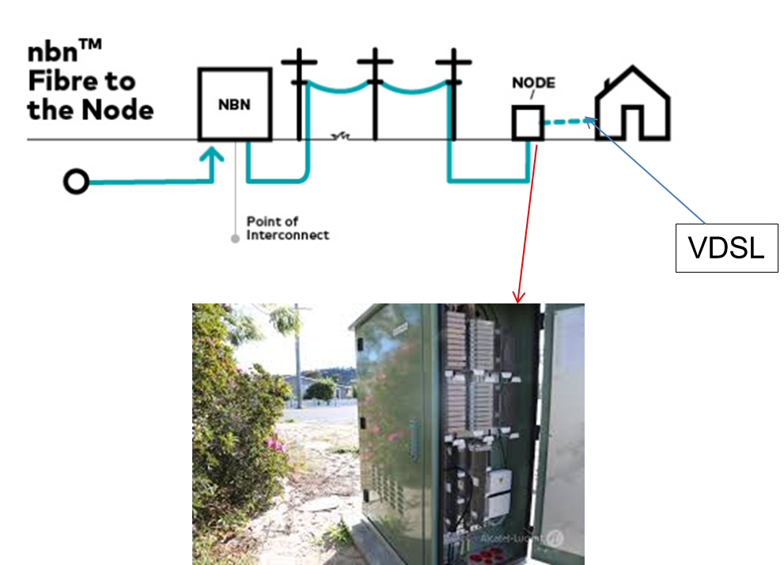

#### VDSL Modem Codes

NBN installations requires VDSL2 with vectoring, hence there are two modem codes that are suitable:

* AnnexA\_574307\_571801
* Annex A \_579C17\_573F01

DrayTek VDSL routers are shipped with modem code “AnnexA\_574307\_571801” pre-installed. This will work with NBN VDSL2 installations as well as ADSL2+ installations. The other modem code “Annex A \_579C17\_573F01” has been developed to improve sync speeds with VDSL2 connections but is not recommended for ADSL+ installations.

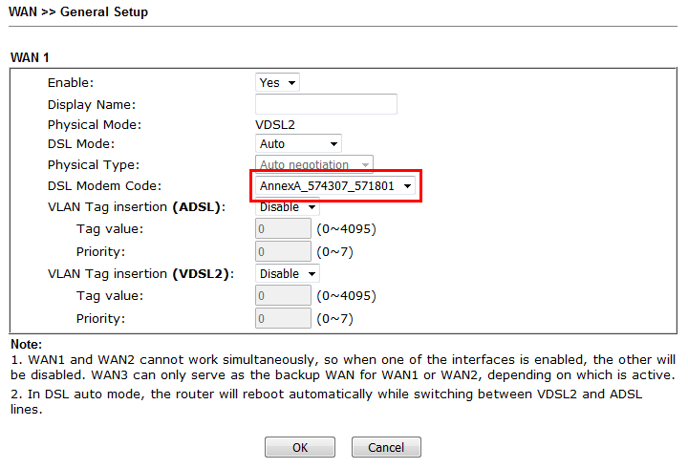

#### VLAN Tag

Many service providers require the use of a VLAN tag to access the NBN. The most common VLAN tag is 100.

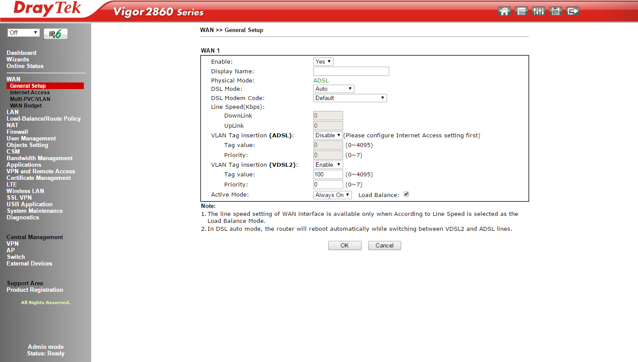

### Checking the VDSL Connection Status

When VDSL connection issues are encountered you can have a look at the **Diagnostics>>DSL status** page in the router. The details on this page will give an indication of error conditions that are affecting the VDSL connection.

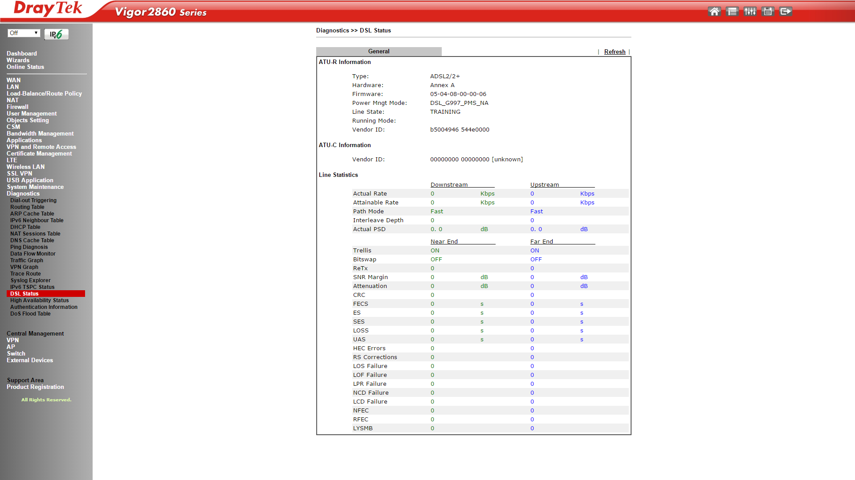

#### NBN VDSL Configuration Examples

There are a number of configuration examples available on the Internet showing how to configure VDSL routers for NBN connections. Below is a list of useful resources:

**Application Notes**

1. NBN Configuration Application notes –

<http://www.i-helpdesk.com.au/index.php?/default_import/Knowledgebase/List/Index/49/nbn>

1. How to Connect DrayTek Vigor router to VDSL2 connection on NBN network –

<http://www.i-helpdesk.com.au/index.php?/default_import/Knowledgebase/Article/View/673/49/how-to-connect-draytek-vigor-router-to-vdsl2-connection-on-nbn-network>

1. Configuring Vigor130 for VDSL Bridge mode –

<http://www.i-helpdesk.com.au/index.php?/default_import/Knowledgebase/Article/View/704/51/configuring-vigor130--for-vdsl-bridge-mode>

**Videos**

1. How to Configure the Vigor 2760 Router for NBN VDSL Network - <https://youtu.be/EMzJxOXeG9U>
2. How to Configure the Vigor2860 Router for VDSL2 Connection on NBN Network - <https://youtu.be/G2U9M4Vp4as>
3. How to Configure the Vigor130 Router for VDSL2 Bridge Mode - <https://youtu.be/DFFr3b1Psoo>

## Ethernet WAN

Another common WAN application is Ethernet WAN, where the user can connect the router to Ethernet switch, cable modem or DSL modem provided by ISP.

The customer can connect the Ethernet WAN on a DrayTek router to a NBN NTU (Network Termination Unit) for services like FTTH/FTTP (Fibre to the Premise), HFC, Satellite, or fixed wireless.

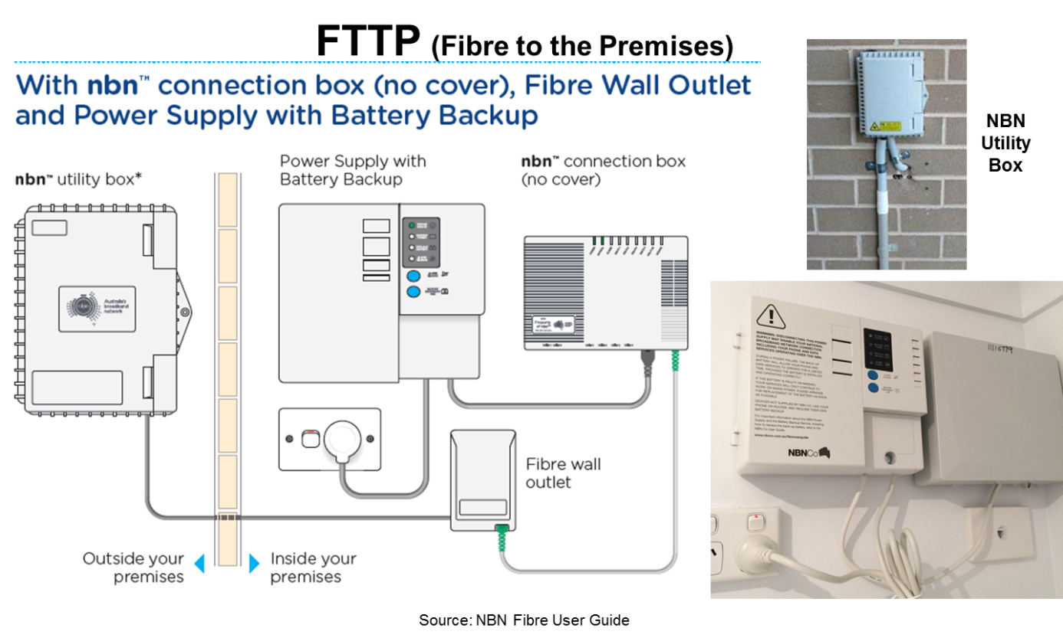

### Configuration of Ethernet WAN

The Ethernet WAN interface can be configured to auto-negotiate the WAN connection speed. You can select a fixed connection speed and duplex setting, for instances where auto negotiation does not work. Some NBN connections will also require a VLAN tag value to be inserted.

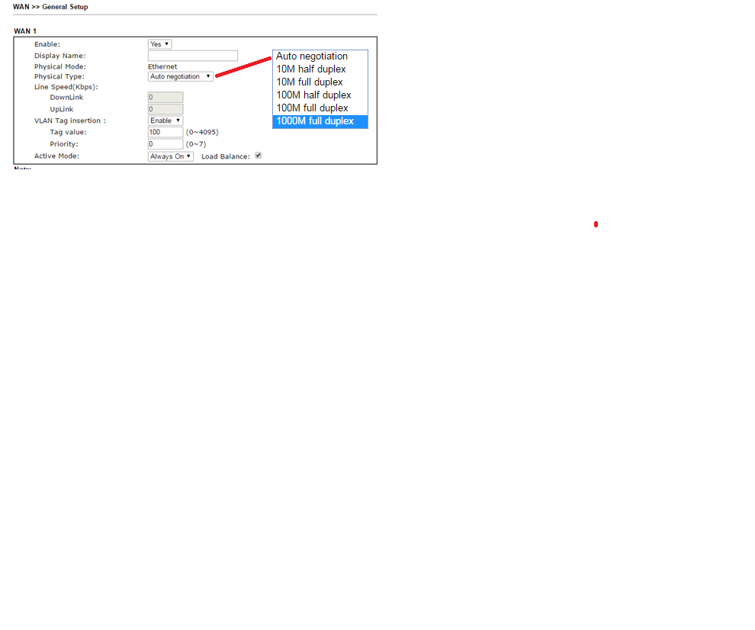

#### WAN Access Mode Settings

There are three modes that can be selected for Internet access. These are: PPPoE, Static or Dynamic IP and PPTP/L2TP.

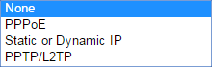

**PPoE**

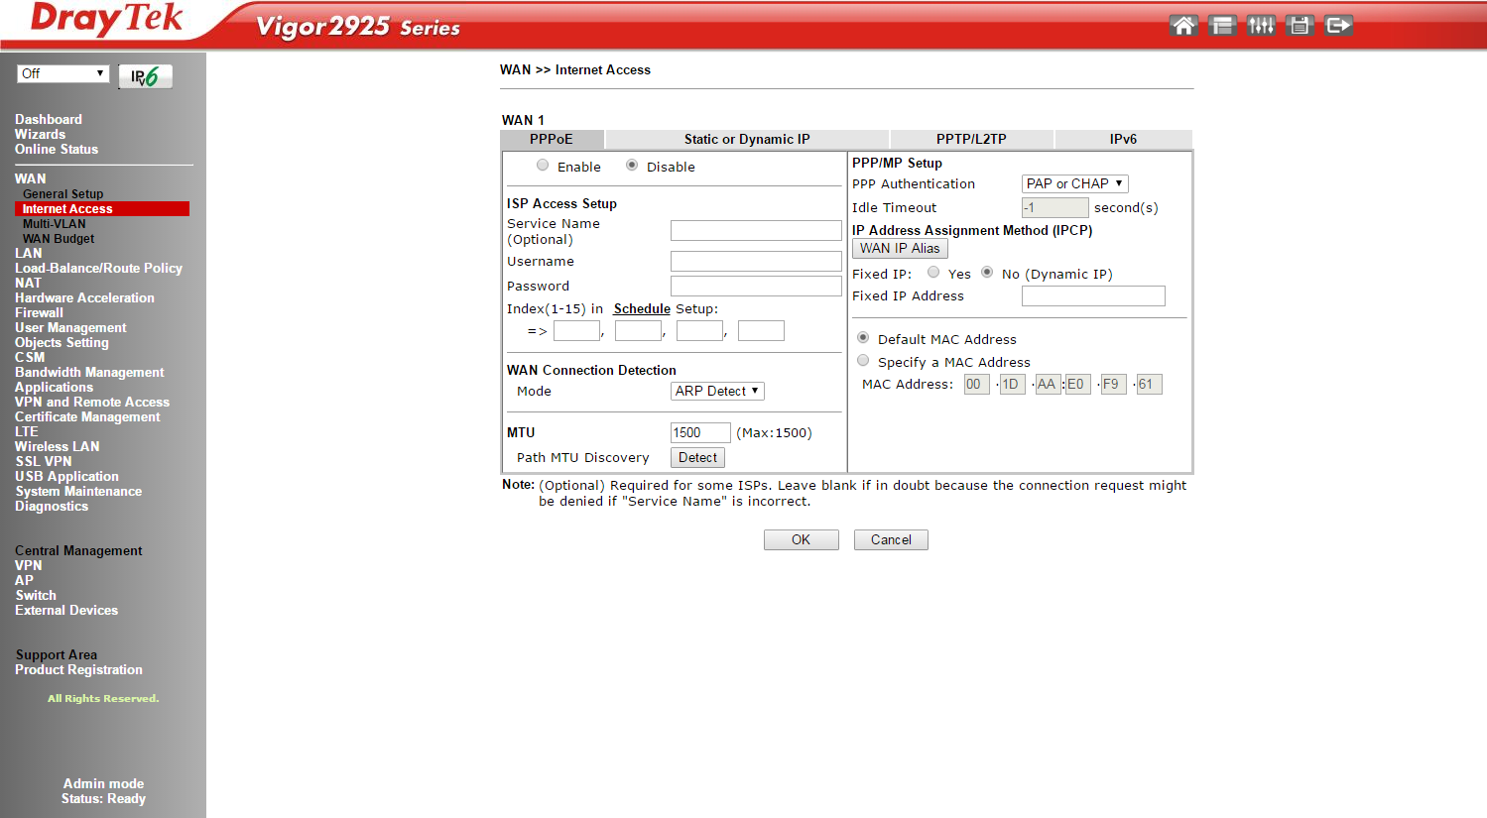

**Static or Dynamic IP**

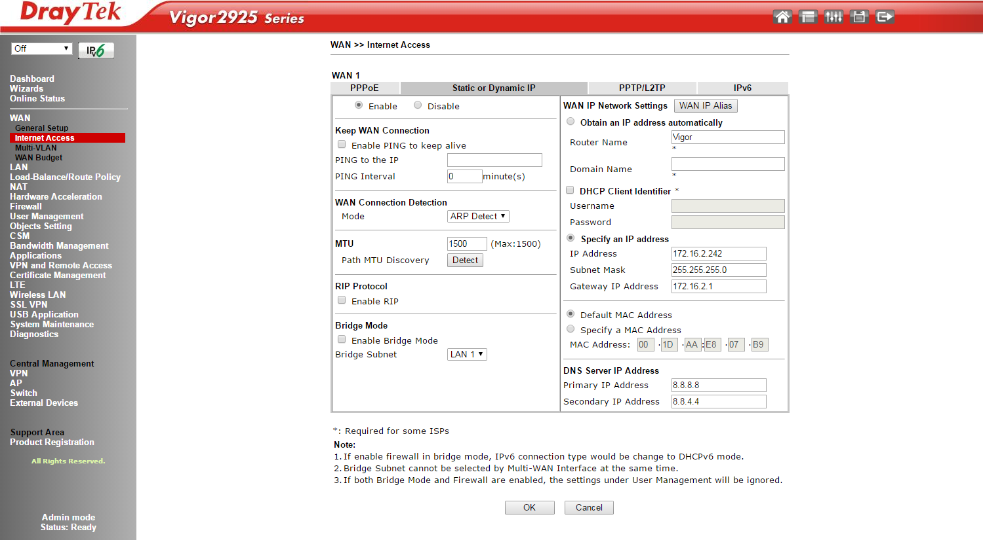

**PPTP/L2TP**

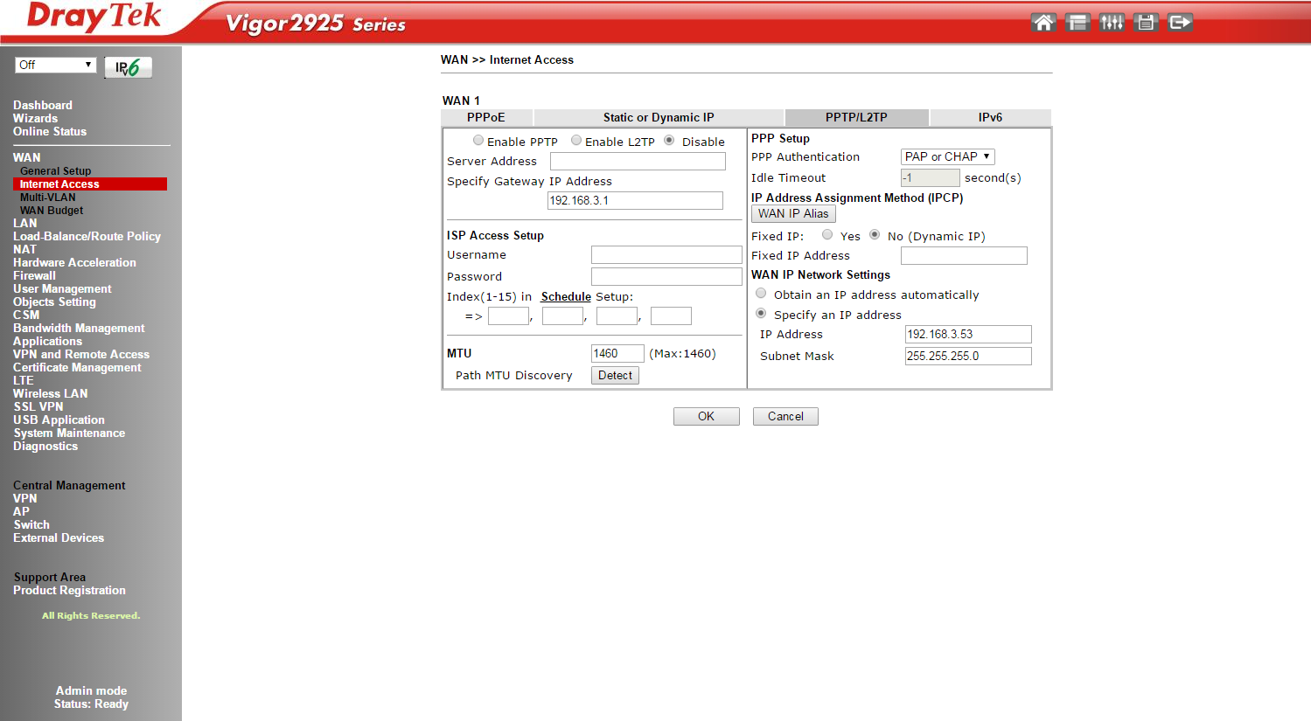

#### NBN Configuration Examples

There are a number of configuration examples available on the Internet showing how to configure DrayTek broadband routers for NBN connections. Below is a list of useful resources:

**Application Notes**

1. NBN Configuration Application notes –

<http://www.i-helpdesk.com.au/index.php?/default_import/Knowledgebase/List/Index/49/nbn>

1. How to Connect a DrayTek Vigor2925 router to DODO NBN –

<http://www.i-helpdesk.com.au/index.php?/default_import/Knowledgebase/Article/View/582/53/how-to-connect-a-draytek-vigor2925-router-to-dodo-nbn>

1. How to Connect a DrayTek Vigor2860 Router to TPG NBN –

<http://www.i-helpdesk.com.au/index.php?/default_import/Knowledgebase/Article/View/664/54/how-to-connect-a-draytek-vigor2860-router-to-tpg-nbn>

1. How to Connect a DrayTek Vigor2860 router to AAPT NBN –

<http://www.i-helpdesk.com.au/index.php?/default_import/Knowledgebase/Article/View/608/66/how-to-connect-a-draytek-vigor2860-router-to-aapt-nbn>

**Video**

1. How to Configure the DrayTek Vigor 2860 for TPG NBN - <https://youtu.be/_hX9Ow0TN0g>

## USB WAN

DrayTek routers also have the flexibility to support 3G and 4G connection with external USB dongle. The list of supported dongles on DrayTek products is available on our web site: [http://www.draytek.com.au/support/3g-4g-modem-compatibility](http://www.draytek.com.au/support/3g-4g-modem-compatibility/)

### WAN Access Modes

There are two access modes available for 3G/4G USB modems. These are PPP mode and DHCP mode.

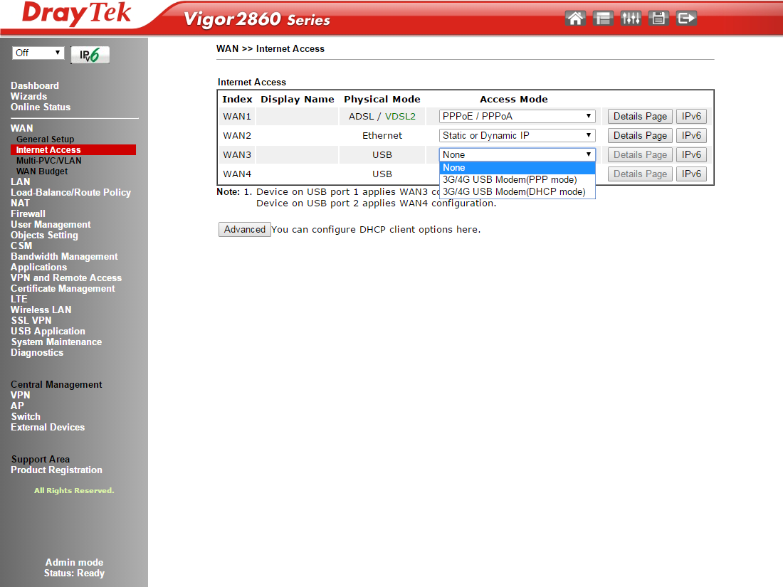

**PPP Mode**

For this mode enter the APN Name (Access Point Name) for the service provider that you will be connecting to. The APN is a gateway between a GSM, GPRS, 3G or 4G mobile networks and another computer network, frequently the public Internet.

For some service providers you may also need to enter a username and password for authentication.

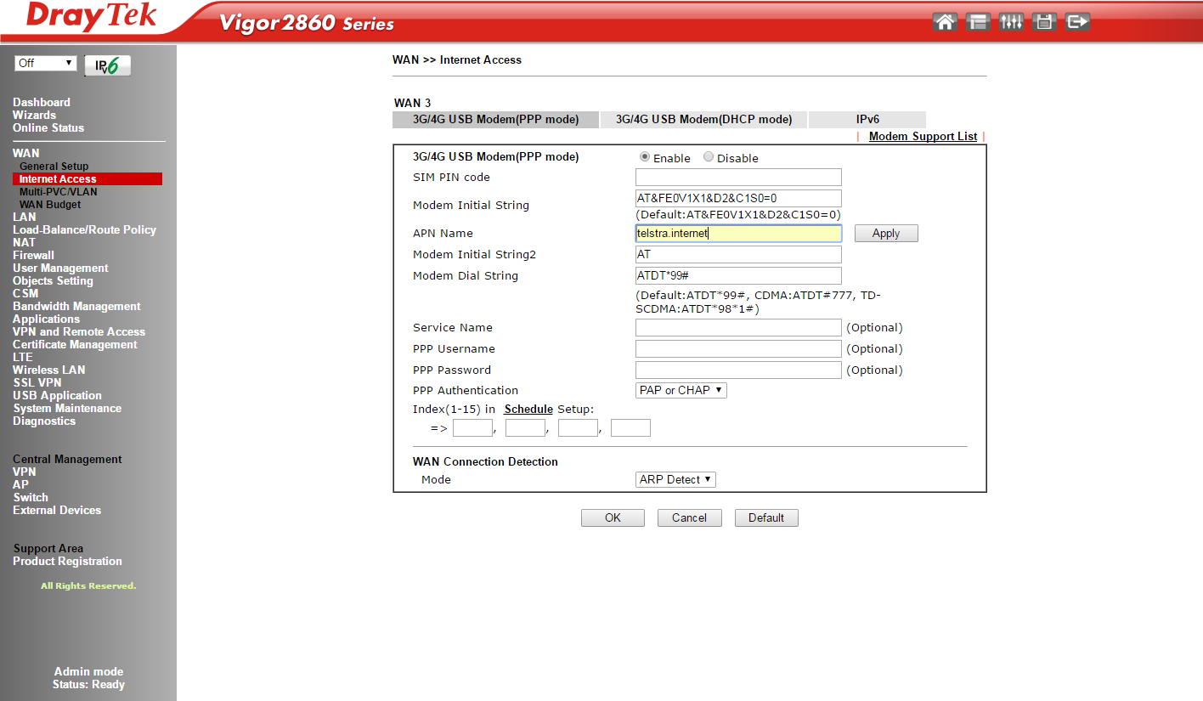

**DHCP Mode**

For DHCP mode you just need to select enable and enter the APN Name.

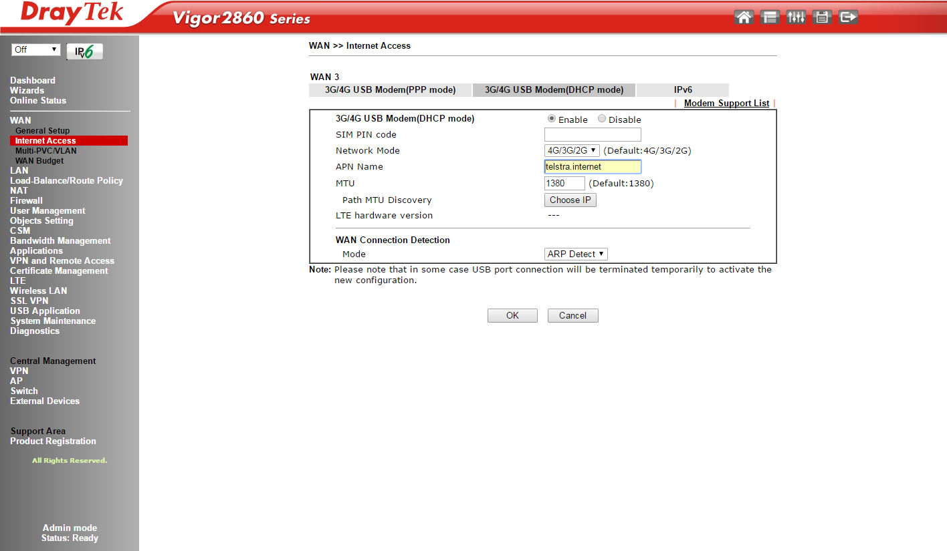

**Notes:**

1. Most service providers now only allocate a private IP address for the 3G/4G WAN connection. This can cause problems for incoming VPN connections. It is possible however with some service providers to request a public IP address for the WAN connection.
2. Most modern 3G/4G USB modems are running NAT so the router will always see a private IP address on the WAN connection. If a public IP address has been assigned to the 3G/4G modem you will need to enable port forwarding in the modem so you can access services on the LAN from the Internet. For example port forward port 5060 for SIP services from the Internet to a server on the LAN.

#### Configuration Examples

There are a number of configuration examples available on the Internet showing how to configure DrayTek routers for 3G/4G connections. Below is a list of useful resources:

**Application Notes**

1. 3G/4G Application notes - <http://www.i-helpdesk.com.au/index.php?/default_import/Knowledgebase/List/Index/33/3g4g>
2. Configure 4G Netgear 320U on Draytek Vigor 2830 – <http://www.i-helpdesk.com.au/index.php?/default_import/Knowledgebase/Article/View/670/33/configure-4g-netgear-320u-on-draytek-vigor-2830>
3. Vigor2960 / 3900 / 300B 4G Configuration - http://www.i helpdesk.com.au/index.php?/default\_import/Knowledgebase/Article/View/606/33/vigor2960--3900--300b-4g-configuration

**Videos**

1. How to Configure the DrayTek Vigor2860 and Vigor2925 Routers for 4G USB WAN Connections - <https://youtu.be/k9b37S7cGlA>
2. Vigor2960 / 3900 /300B 4G Configuration - <https://youtu.be/A8DM5-nPZMw>

## LTE WAN

LTE WAN routers support 4G LTE connection with the embedded 4G LTE modem. This function is available in Vigor2860L and Vigor2925L series.

|  |  |
| --- | --- |
|  | LTE routers are unlocked and accept SIM cards from major providers:   * Australia: Telstra, Optus, Vodafone, etc. * New Zealand: Spark, 2Degrees and Vodafone   Have a built in SIM card slot with cover protection. |

Supported are 4 G LTE bands are:

* B3 (1800MHz)
* B7 (2600MHz)
* B8 (900MHz)
* B20 (800MHz)

***Note 1: Band 28 (700MHz) and3G WCDMA Band 5 (850MHz) is currently not supported***

The maximum data rate for downlink is 150Mbps and the data rate for uplink is 50Mbps.

### LTE Configuration

Ensure the SIM card is inserted into the SM card slot as shown in the diagram above paying attention to the notch in the SIM card.

LTE Access Mode configuration is only available for DHCP mode.

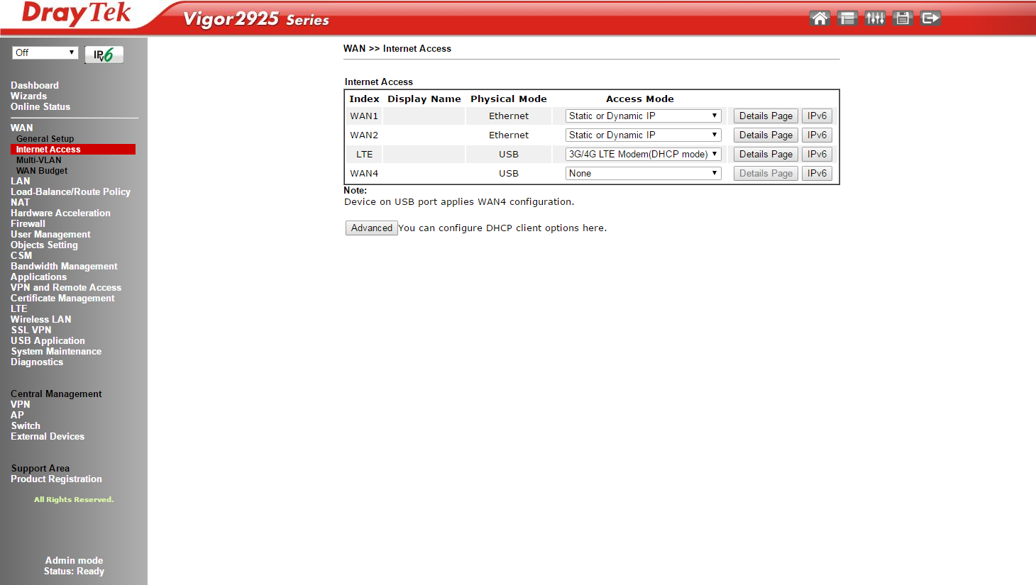

Enter the relevant details including the APN Name.

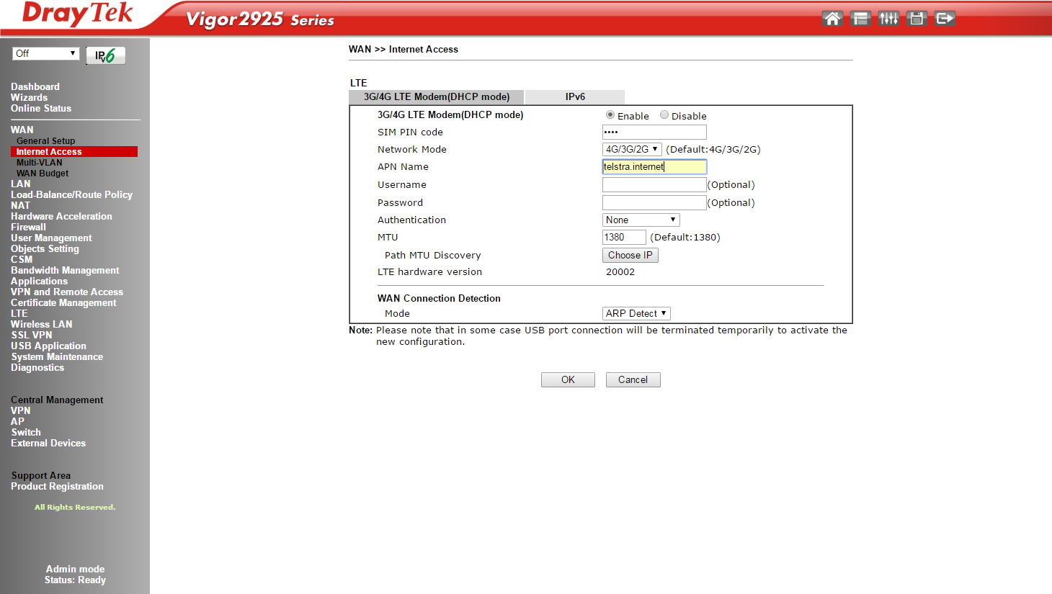

**Notes**

1. Most service providers now only allocate a private IP address for the 3G/4G WAN connection. This can cause problems for incoming VPN connections. It is possible however with some service providers to request a public IP address for the WAN connection.
2. In some instances when using 4G modems the assigned public IP address may not be sent to the modem via DHCP. To overcome this DrayTek have added a CLI command to manually assign an IP address for the WAN connection. For example to manually assign a fixed IP address for the LTE WAN use the command:

* ***wan lte set fixed 1.1.1.1***

#### Video Demonstration

**Configuring the Vigor2860L and Vigor2925L for LTE Internet Access**

[**https://youtu.be/iLWPmZyen6g**](https://youtu.be/iLWPmZyen6g)

### Checking the Status of LTE WAN

You can view the current status of the LTE WAN connection by going to **LTE >> Status** menu in the router. Here you can check the LTE details including the LTE band used, signal strength etc.

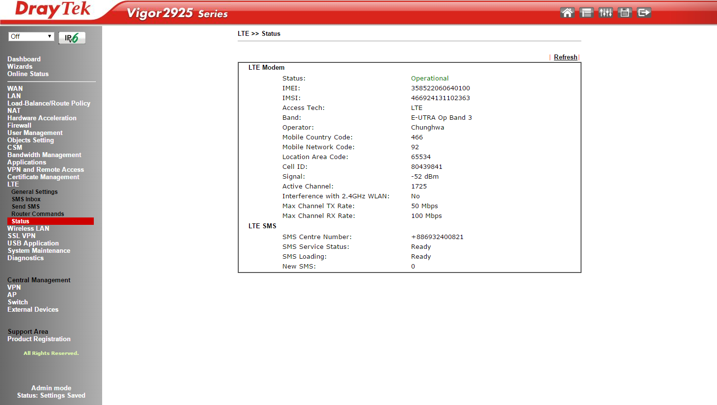

#### Configuration Examples

There are a number of configuration examples available on the Internet showing how to configure DrayTek routers for LTE connections. Below is a list of useful resources:

**Application Notes**

1. Configuring the Vigor2860L and Vigor2925L for LTE Internet access

<http://www.i-helpdesk.com.au/index.php?/default_import/Knowledgebase/Article/View/693/33/configuring-the-vigor2860l-and-vigor2925l-for-lte-internet-access>

1. Troubleshooting LTE Connectivity Issues with DrayTek LTE Routers

<http://www.i-helpdesk.com.au/index.php?/default_import/Knowledgebase/Article/View/709/33/troubleshooting-lte-connectivity-issues-with-draytek-lte-routers>

1. How to check if the DrayTek Vigor2860/2925 LTE Router Frequency Bands are supported on your Area

<http://www.i-helpdesk.com.au/index.php?/default_import/Knowledgebase/Article/View/710/33/how-to-check-if-the-draytek-vigor28602925-lte-router-frequency-bands-are-supported-on-your-area>

**Video**

1. Configuring the Vigor2860L and Vigor2925L for LTE Internet Access –

<http://www.i-helpdesk.com.au/index.php?/default_import/Knowledgebase/Article/View/695/33/video---configuring-the-vigor2860l-and-vigor2925l-for-lte-internet-access>

## Fibre WAN

Fibre WAN connections are available on the Vigor3900 and Vigor2952 routers. These routers have a Small Form-factor Pluggable (SFP) slot and will accept the installation of a SFP fibre module to allow connection to fibre optic cable.



**SFP Slot**

Configuration of the WAN Interface is similar to that of the Ethernet WAN Interface.

## Wireless (Wi-Fi) WAN

The Wireless WAN (Wi-Fi WAN) is a new feature that has been added to the Vigor2860n/ac and Vigor2925n/ac routers. It allows the user to connect the router to any Wi-Fi hotspot or Wi-Fi tethering from a mobile phone. This function is useful during an emergency when all wired connections are dropped and no 4G USB dongle is available.

WAN 2 can be configured to use the Gigabit Ethernet WAN port of to use the router’s Wireless connection.

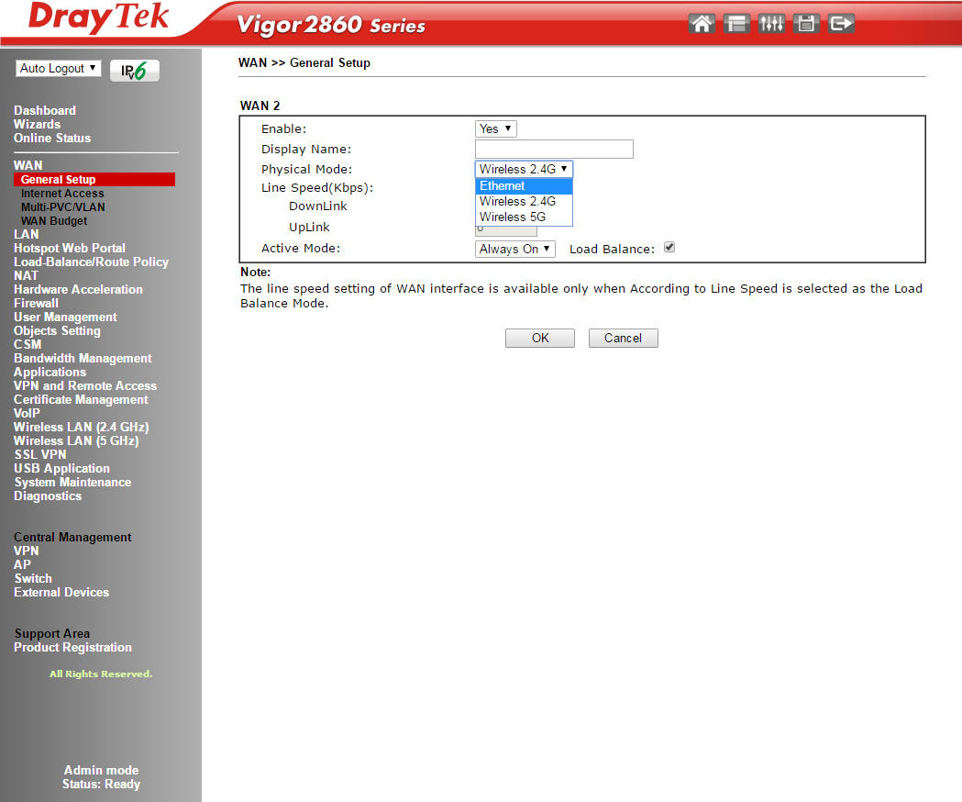

### Configuring Wireless WAN

After enabling Wireless WAN for WAN 2 in **WAN >> General Setup** configuration menu, go to **WAN >> Internet Access>>WAN2** details page.

* Use the AP Discovery tool to search for available Wi-Fi Hotspots.
* Select the required Hotspot and add it to Universal Repeater Parameters section on this page.

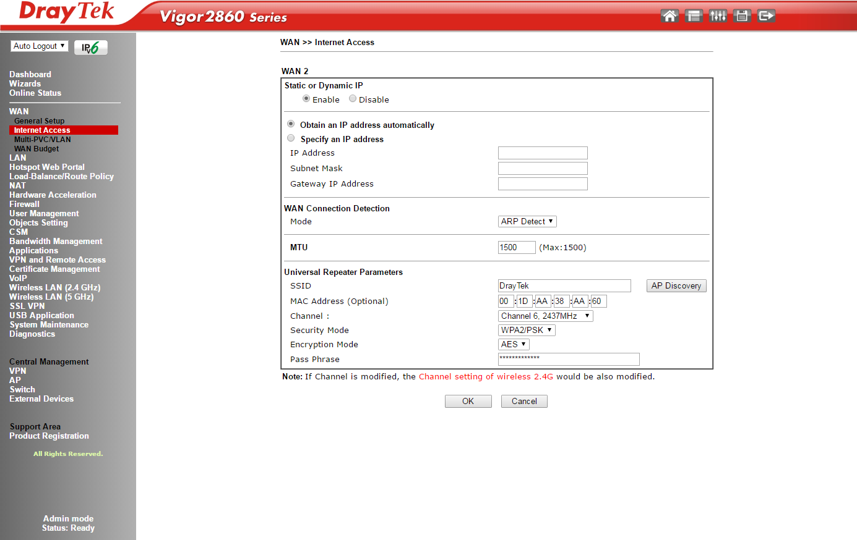

#### Video Demonstration

**How to set up a wireless WAN in Vigor Router**

[**https://youtu.be/hRw4AtdVAgM**](https://youtu.be/hRw4AtdVAgM)

#### Detailed Wireless WAN Configuration Steps

Vigor2860n/ac and Vigor2925n/ac routers running firmware version 3.8.1 or later, support the Wireless WAN feature.

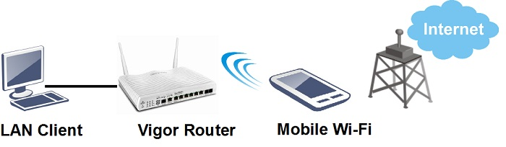

1. Enable Wireless LAN function on the router: Go to Wireless LAN (2.4GHz) >> General Setup, and enable Wireless LAN.

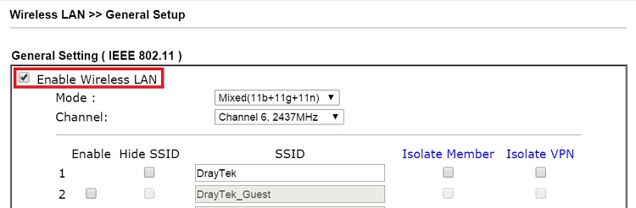

1. Change the Physical Mode of WAN 2: Go to WAN >> General Setup >> WAN2, set Physical Mode as "Wireless", click OK to apply and reboot the router.

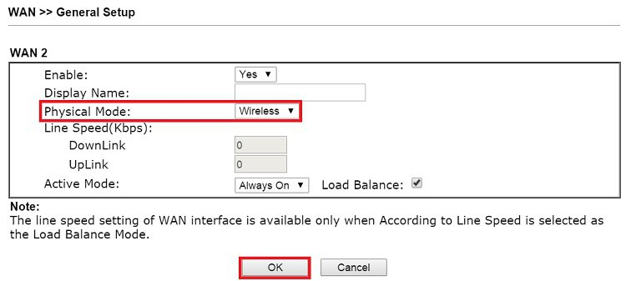

1. Go to WAN >> Internet Access, you will see the WAN2's Physical Mode changed to "Wireless". Set Access Mode as "Static or Dynamic IP" and click Details Page to setup.

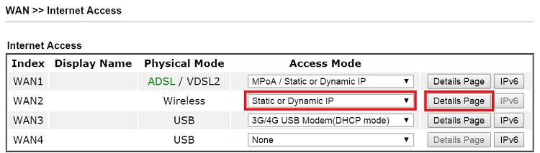

4. Enter the details for Wi-Fi connection:

* Enable Static or Dynamic IP
* Set up IP address as required.
* Set up Universal Repeater Parameters, you may use AP Discovery to find available access point.
* Enter Pass Phrase for the SSID.
* Click OK to apply and reboot the router.

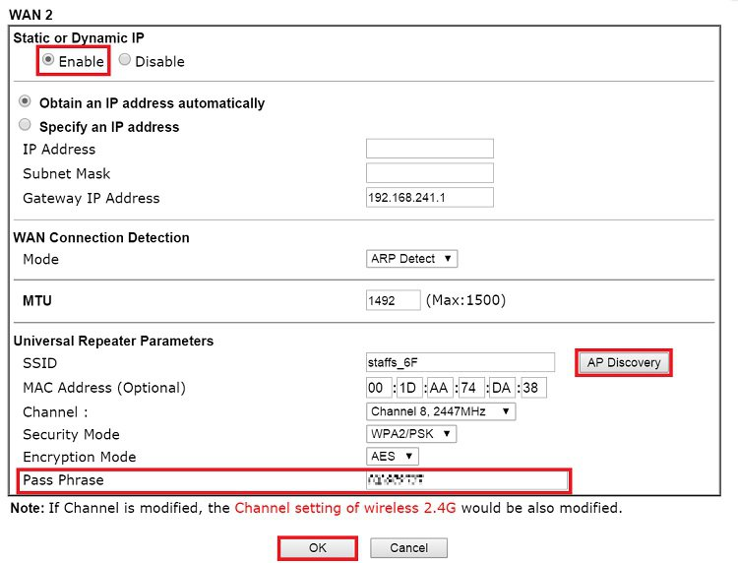

1. After the router reboots, check the WAN connection status via Online Status >> Physical Connection.

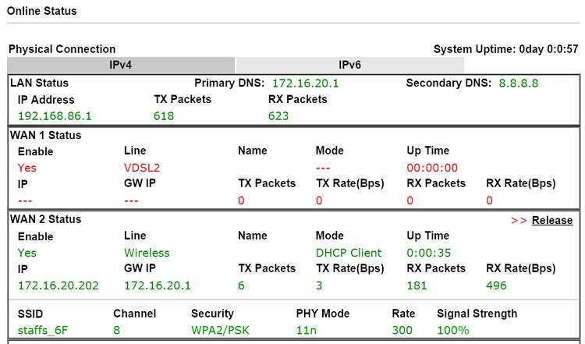

### Additional Resources

**Video**

How to set up a wireless WAN in Vigor Router

<https://youtu.be/hRw4AtdVAgM>

## Exercises

1. Configure and test Vigor LTE router for LTE WAN connectivity.
2. Configure and test Wi-Fi WAN for Vigor2860n/ac or Vigor2925n/ac